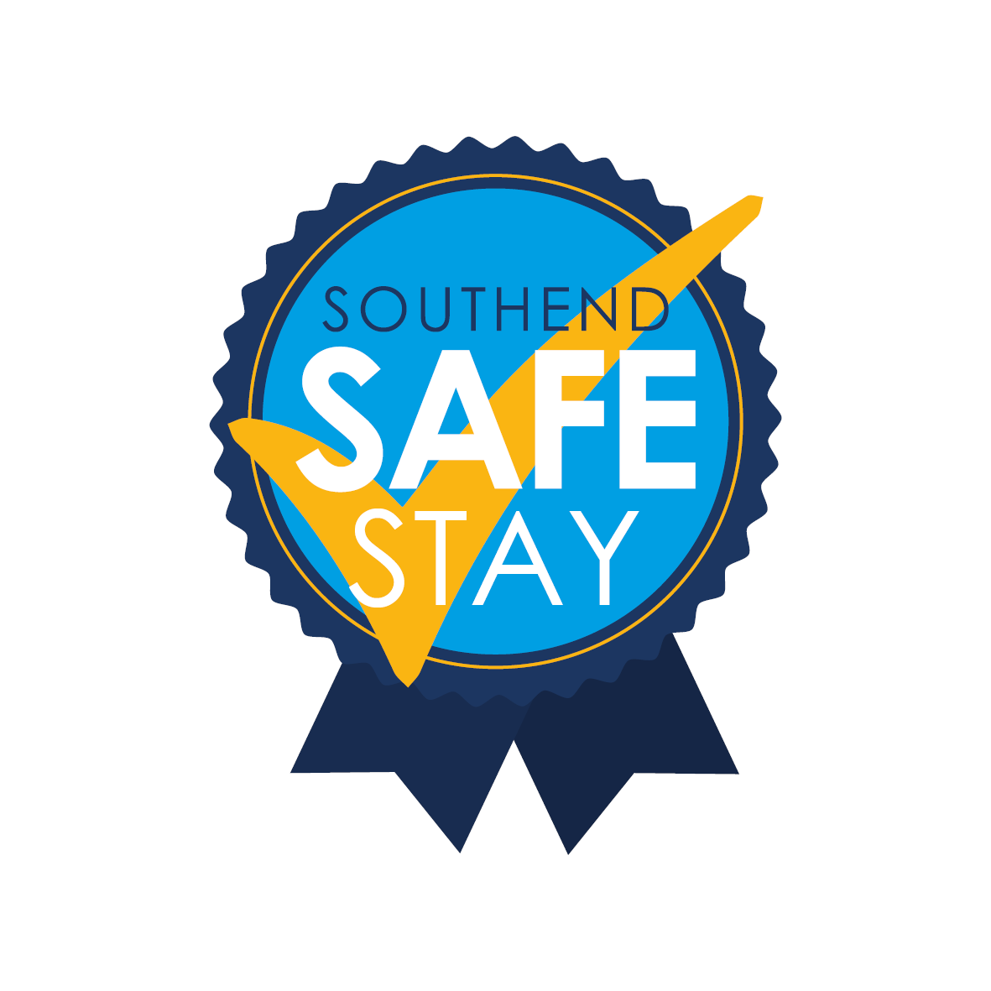

Covid-19 Risk Assessment
Name of Business
Name of Manager
Date of Initial Assessment

Covid-19 is a new illness that can affect your lungs and airways. It is caused by a virus called Coronavirus. Symptoms can be mild, moderate, severe or fatal. This is a draft copy of a generic Risk Assessment for dealing with the current Covid-19 situation in the workplace. It is not likely to cover all scenarios and each employer should consider their own unique circumstances. Much more specific assessments, may look quite different although many of the principles would still be relevant. To keep up to date with advice to workplaces in this fast changing situation visit https://www.gov.uk/guidance/working-safely-during-coronavirus-covid-19
What is the Hazard: Spread of Covid-19 Coronavirus
Who might be harmed: Staff, Customers, Visitors to the premises, Cleaners, Contractors, Vulnerable groups – Elderly, Pregnant workers, those with existing underlying health conditions, Anyone else who physically comes in contact with us in relation to our business.
What are the hazards? | Who might be harmed | Controls Required | Additional Controls | Action by who? | Action by when? | Done
Spread of Covid-19 Coronavirus | - Staff  - Visitors to your premises  - Cleaners  - Contractors  - Drivers  - Vulnerable groups – Elderly, Pregnant workers, those with existing underlying health conditions  - Anyone else who physically comes in contact with you in relation to your business | Hand Washing  - Hand washing facilities with soap and water in place.  - Stringent hand washing taking place.  - See hand washing guidance.  - https://www.nhs.uk/live-well/healthy-body/best-way-to-wash-your-hands/  - Drying of hands with disposable paper towels.  - https://www.nursingtimes.net/news/research-and-innovation/paper-towels-much-more-effective-at-removing-viruses-than-hand-dryers-17-04-2020/  - Staff encouraged to protect the skin by applying emollient cream regularly  - https://www.nhs.uk/conditions/emollients/  - Gel sanitisers in any area where washing facilities not readily available  Cleaning  Frequently cleaning and disinfecting objects and surfaces that are touched regularly particularly in areas of high use such as door handles, light switches, reception area using appropriate cleaning products and methods.  Social Distancing  Social Distancing -Reducing the number of persons in any work area to comply with the 2-metre (6.5 foot) gap recommended by the Public Health Agency  https://www.gov.uk/government/publications/covid-19-guidance-on-social-distancing-and-for-vulnerable-people  Taking steps to review work schedules including start & finish times/shift patterns, working from home etc. to reduce number of workers on site at any one time. Also relocating workers to other tasks.  Redesigning processes to ensure social distancing in place.  Conference calls to be used instead of face to face meetings.  Ensuring sufficient rest breaks for staff.  Social distancing also to be adhered to in canteen area and smoking area.  Wearing of Gloves  Where Risk Assessment identifies wearing of gloves as a requirement of the job, an adequate supply of these will be provided. Staff will be instructed on how to remove gloves carefully to reduce contamination and how to dispose of them safely.  RPE  Public Health guidance on the use of PPE (personal protective equipment) to protect against COVID-19 relates to health care settings. In all other settings individuals are asked to observe social distancing measures and practice good hand hygiene behaviours  Where RPE is a requirement for risks associated with the work undertaken the following measures will be followed-  Tight-fitting respirators (such as disposable FFP3 masks and reusable half masks) rely on having a good seal with the wearer’s face. A face fit test will be carried out to ensure the respiratory protective equipment (RPE) can protect the wearer.  Wearers must be clean shaven.  Symptoms of Covid-19  If anyone becomes unwell with a new continuous cough or a high temperature in the workplace they will be sent home and advised to follow the stay at home guidance.  Line managers will maintain regular contact with staff members during this time.  If advised that a member of staff or public has developed Covid-19 and were recently on our premises (including where a member of staff has visited other work place premises such as domestic premises), the management team of the workplace will contact the Public Health Authority to discuss the case, identify people who have been in contact with them and will take advice on any actions or precautions that should be taken.  Drivers  Procedures in place for Drivers to ensure adequate welfare facilities available during their work - Reference  https://www.hse.gov.uk/news/drivers-transport-delivery-coronavirus.htm  COVID-19-guidance on freight transport.  Persons should not share vehicles or cabs, where suitable distancing cannot be achieved.  Mental Health  Management will promote mental health & wellbeing awareness to staff during the Coronavirus outbreak and will offer whatever support they can to help  Reference -  https://www.mind.org.uk/information-support/coronavirus-and-your-wellbeing/ | Employees to be reminded on a regular basis to wash their hands for 20 seconds with water and soap and the importance of proper drying with disposable towels. Also reminded to catch coughs and sneezes in tissues – Follow Catch it, Bin it, Kill it and to avoid touching face, eyes, nose or mouth with unclean hands. Tissues will be made available throughout the workplace.  Encourage staff to report any problems and carry out skin checks as part of a skin surveillance programme  https://www.hse.gov.uk/skin/professional/health-surveillance.htm  To help reduce the spread of coronavirus (COVID-19) reminding everyone of the public health advice -  https://www.hse.gov.uk/news/coronavirus.htm  Posters, leaflets and other materials are available for display.  https://www.gov.uk/government/publications/guidance-to-employers-and-businesses-about-covid-19  Rigorous checks will be carried out by line managers to ensure that the necessary procedures are being followed.  Staff to be reminded on a daily basis of the importance of social distancing both in the workplace and outside of it.  Management checks to ensure this is adhered to.  Staff to be reminded that wearing of gloves is not a substitute for good hand washing.  To minimise the risk of transmission of COVID-19 during face-fit testing the following additional measures should be carried out –  Both the fit tester and those being fit tested should wash their hands before and after the test.  Those being fit tested with non-disposable masks should clean the mask themselves before and immediately after the test using a suitable disinfectant cleaning wipe (check with manufacturer to avoid damaging the mask).  Test face pieces that cannot be adequately disinfected (e.g. disposable half masks) should not be used by more than one individual.  Fit testers should wear disposable gloves when undertaking cleaning of the tubes, hoods etc. and ensure they remove gloves following the correct procedure (PDF)  Reference https://www.hse.gov.uk/news/face-mask-ppe-rpe-coronavirus.htm  Internal communication channels and cascading of messages through line managers will be carried out regularly to reassure and support employees in a fast changing situation.  Line managers will offer support to staff who are affected by Coronavirus or has a family member affected.  Communicate with companies we deliver to/from to ensure welfare facilities will be available to our drivers. Allowing delivery drivers adequate breaks to avail of proper welfare facilities.  Regular communication of mental health information and open door policy for those who need additional support.

